**NAAN MUDHAVAN**

**PROJECT DOCUMENT**

**COURSE TITLE** : DIGITAL MARKETING

**COLLEGE CODE** : 1105

**COLLEGE NAME** : GOJAN SCHOOL OF BUSINESS AND TECHNOLOGY

**PROJECT TITLE** : CREATING BLOG USING WORDPRESS PLATFORM

**PROJECT TEAM ID** : NM2023TMID05694

**TEAM LEADER**

**NM ID** : 1DB9BD359D8BD69A0174EF1D29750B94

**NAME** : NISHA.G

**TEAM MEMBER 1**

**NM ID** 7492A510F88050D9841493828D11A81

**NAME** : RAMYA.R

**TEAM MEMBER 2**

**NM ID** 050ED93DAAD6921A6254F1CCD666CCBB

**NAME** : VEDAVALLI.R

**TEAM MEMBER 3**

**NM ID** 71A774B253C86318C234B583082838DF

**NAME** : YOGESH.J

**TEAM MEMBER 4**

**NM ID** : 445D7708D401D6F89684C91AFD22C748

**NAME** : KOWSALYA.S

**CREATING BLOG USING WORDPRESS PLATFORM**

## BRAND NAME : FASHION ART

## CATEGORY : DIGITAL MARKETING

## BRAND MAIL-ID : [fashionart2423@gmail.com](mailto:fashionart2423@gmail.com)

## PASSWORD : nisharamya

## SOCIAL MEDIA LINK : <https://www.facebook.com/profile.php?id=61552594053809>

## DRIVE LINK : <https://drive.google.com/drive/folders/1mzmce5lwcKGDx9gDkbwk1gCjMndZDCTT?usp=drive_link>

## WORDPRESS BLOG URL :<https://sa9642.wordpress.com/2023/10/22/fashion-art/>

**BRAND LOGO:**



**POSTER:**



**WORDPRESS BLOG URL:** [**https://sa9642.wordpress.com/2023/10/22/fashion-art/**](https://sa9642.wordpress.com/2023/10/22/fashion-art/)

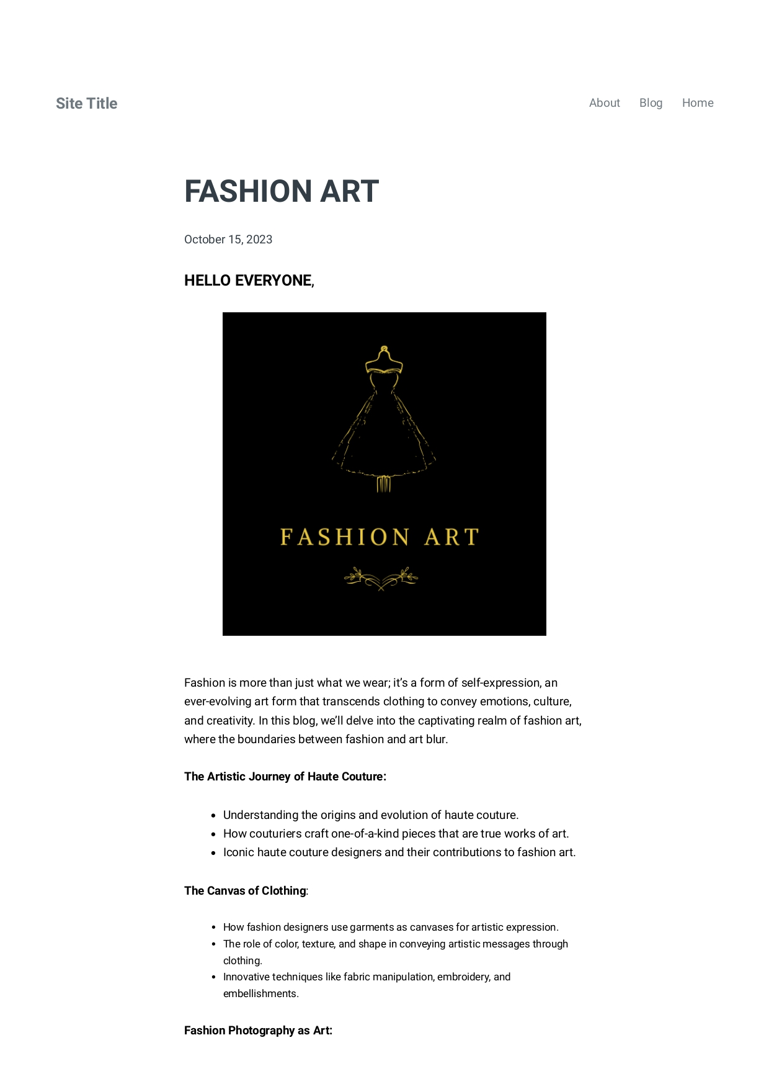

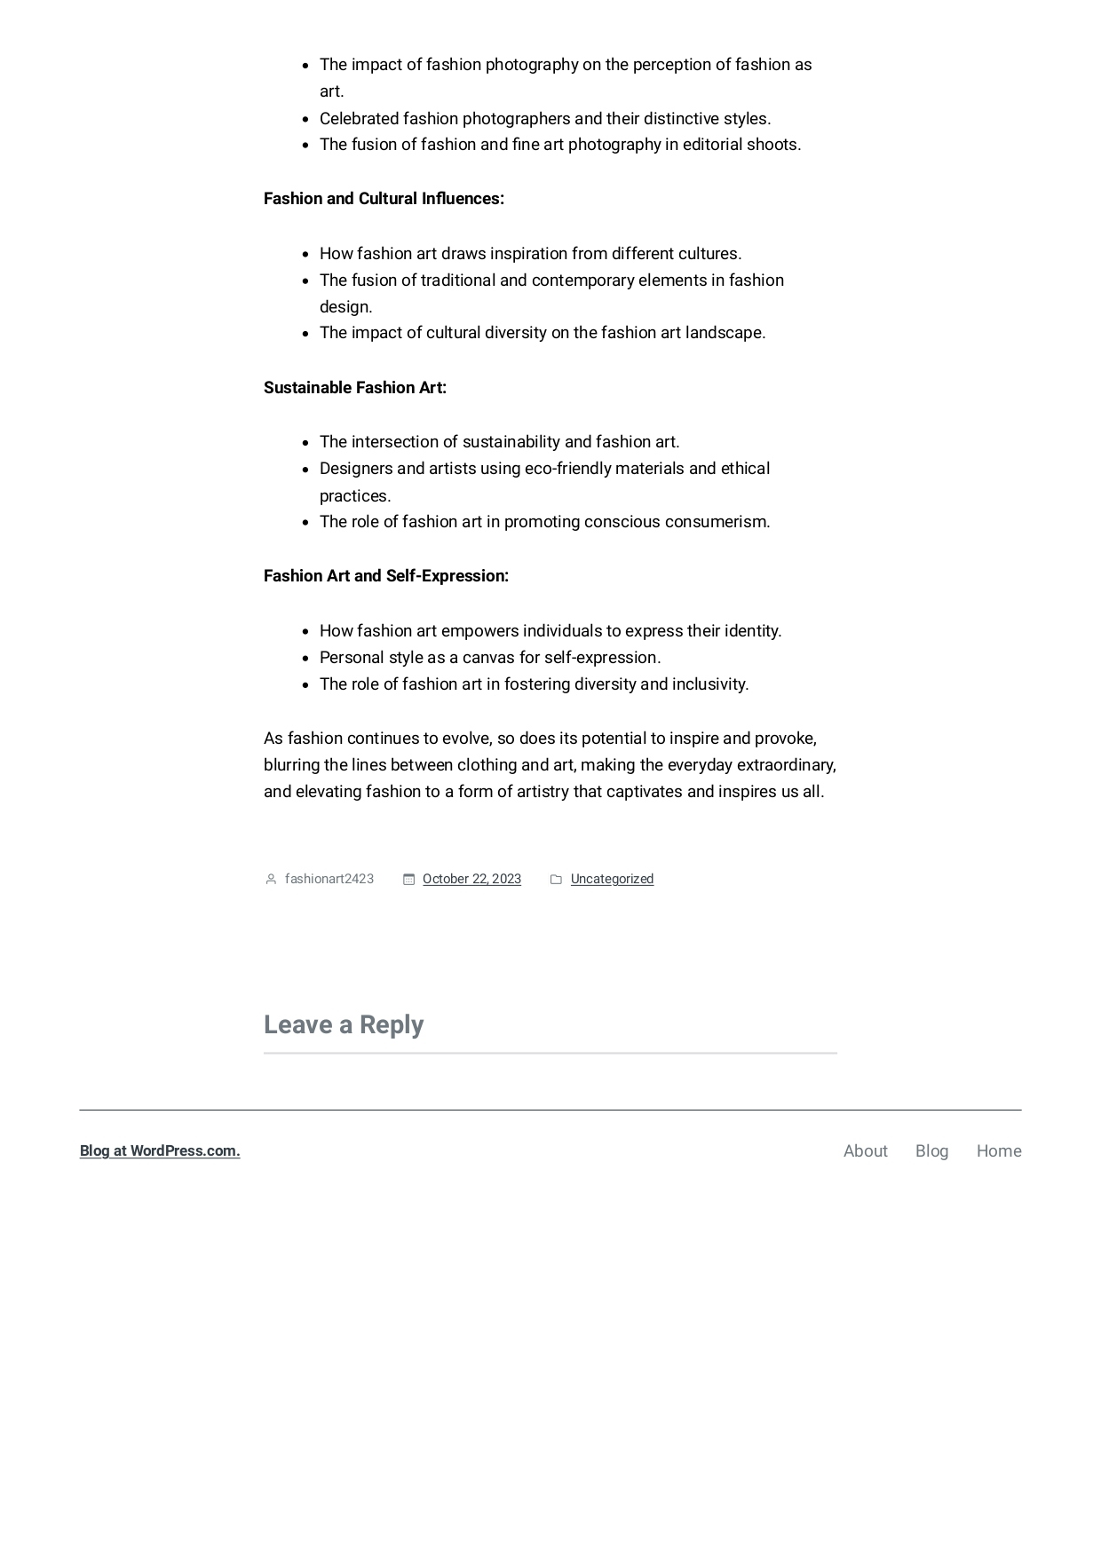

**EMPATHY MAP:**

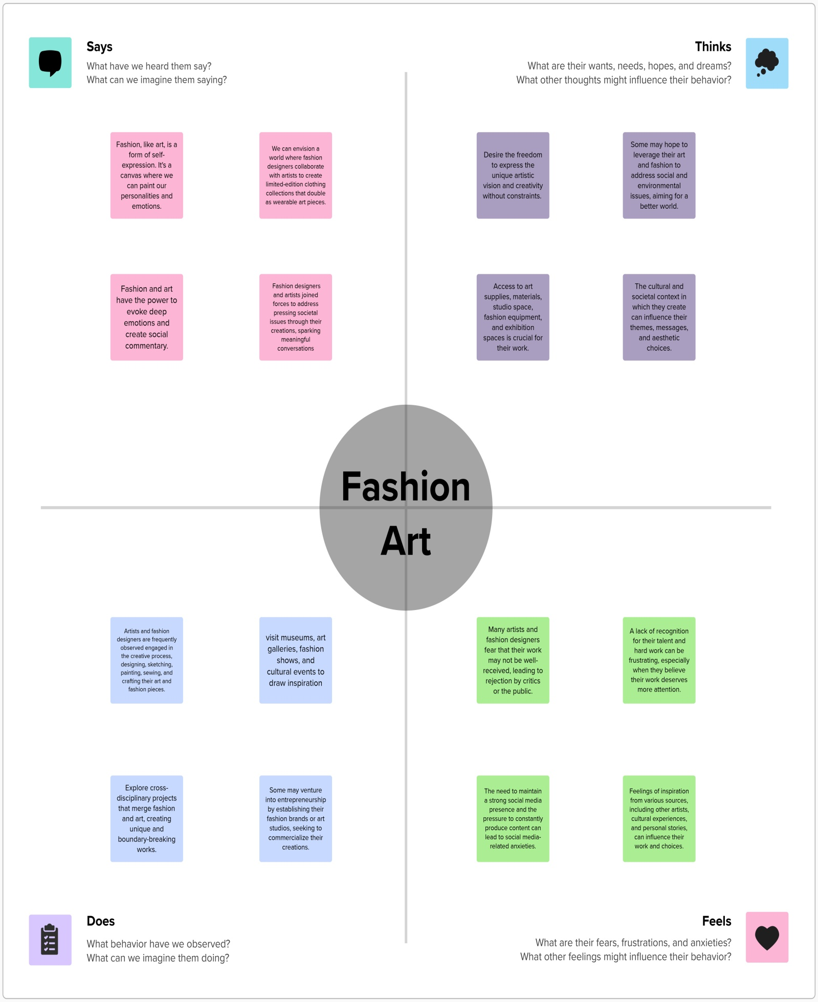

**BRAINSTORMIMG:**

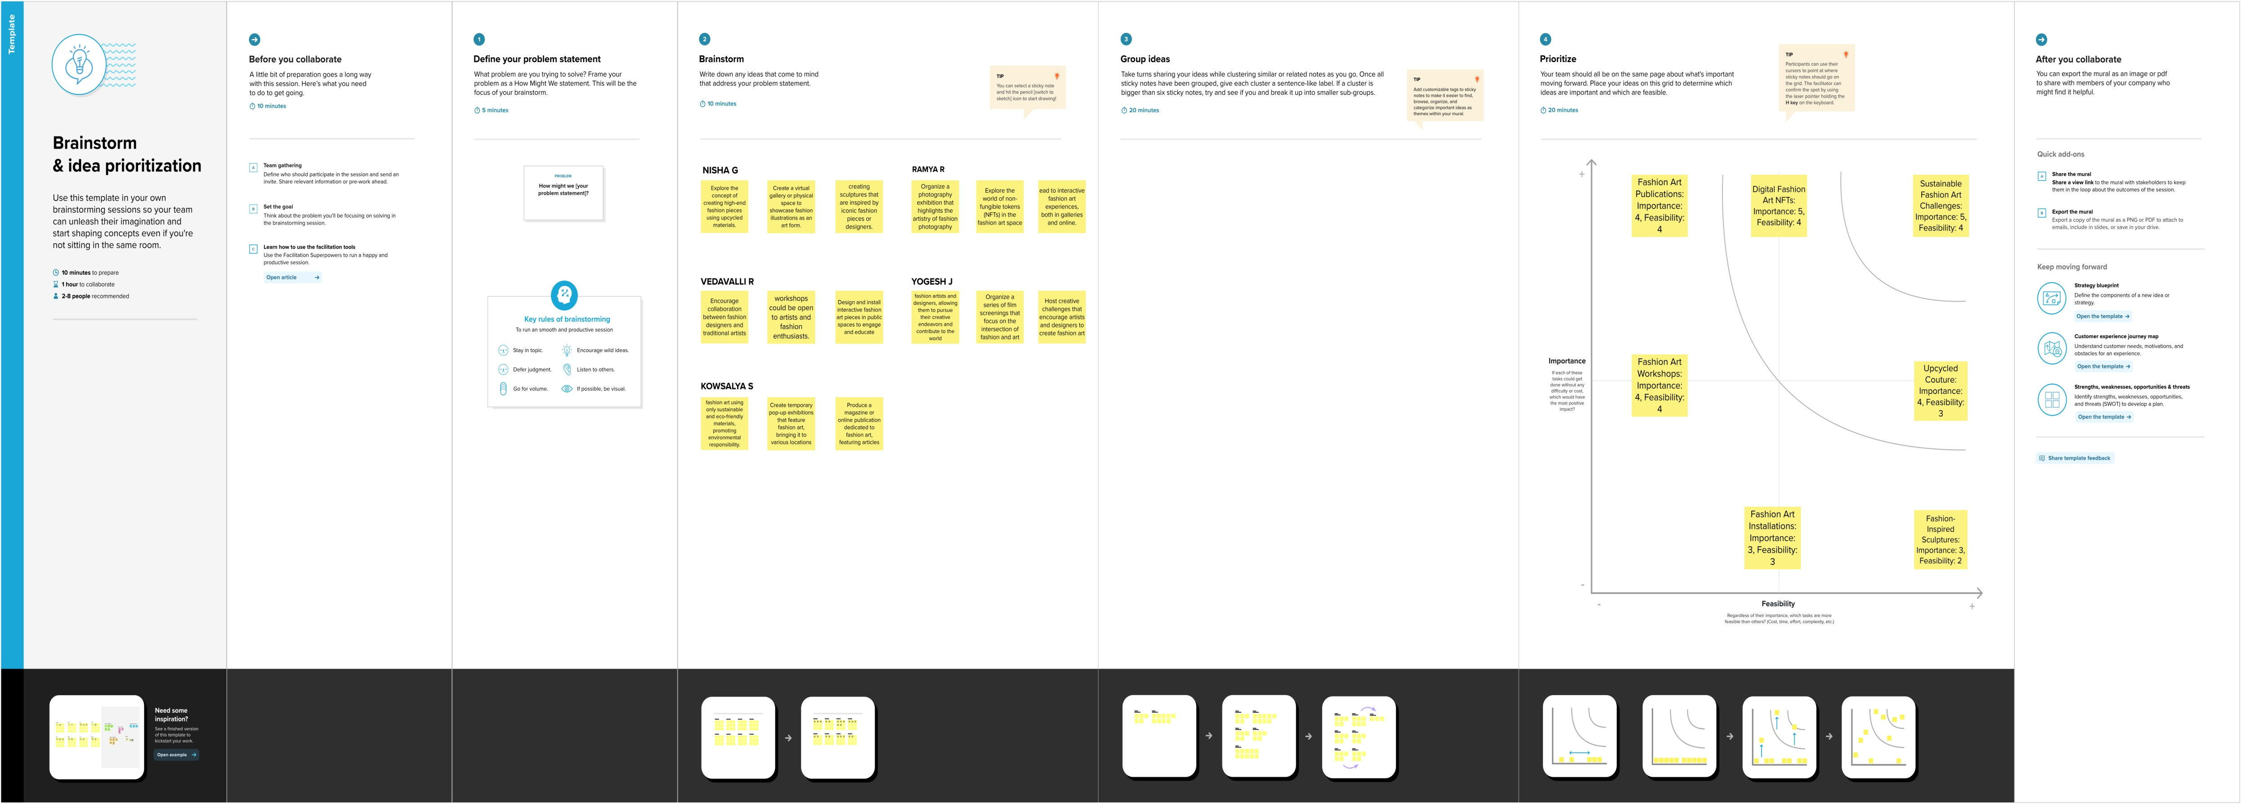

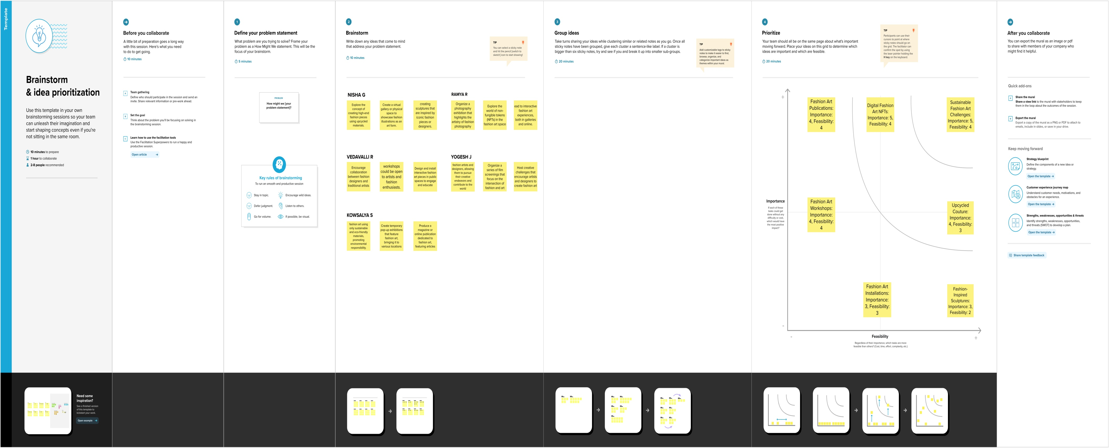

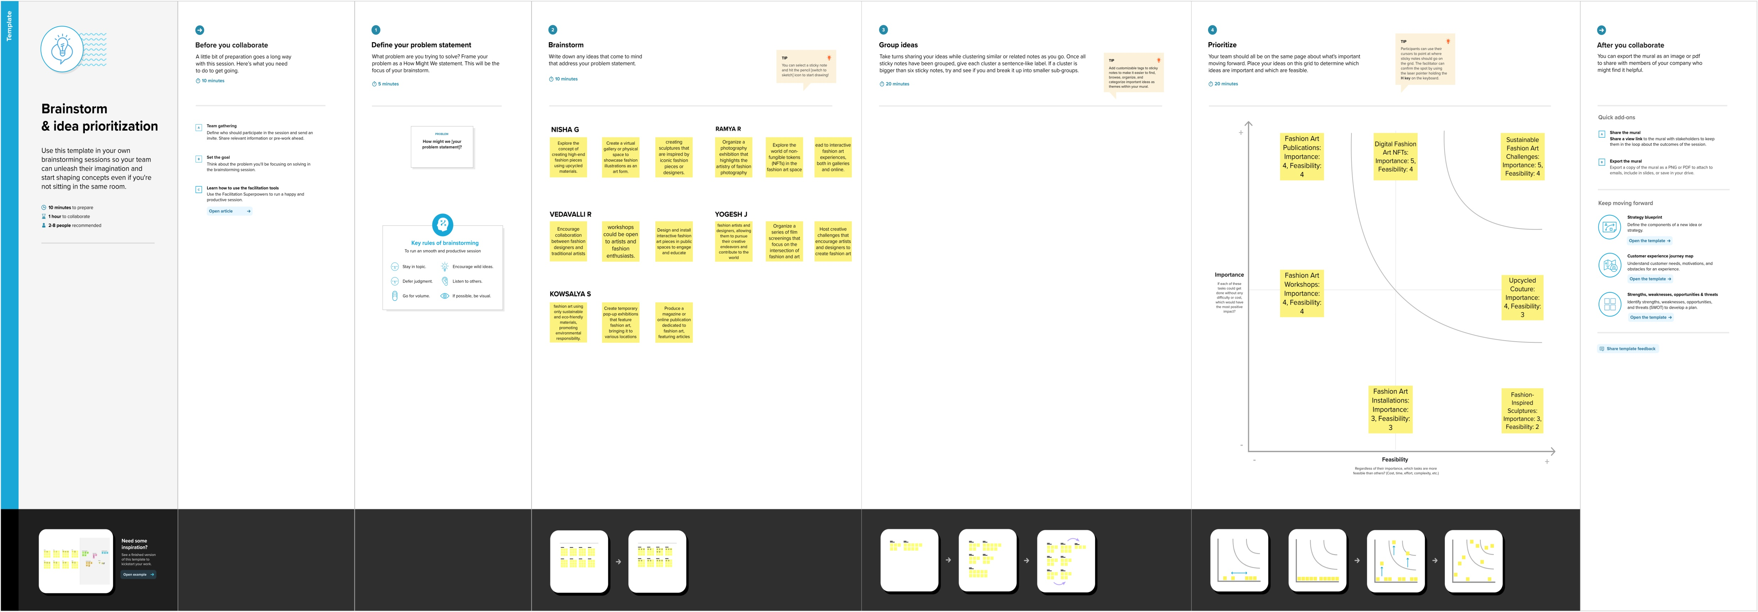

## SOCIAL MEDIA LINK : [https://www.facebook.com/profile.php?id=61552594053809Screenshot (29).png](https://www.facebook.com/profile.php?id=61552594053809#)

## Screenshot (30).png

